EcoChef AI

Kyonne Robinson, Anthony White, Ian Kinney, Jason Scott

# Project Summary

EcoChef AI provides a customized, flexible, and entertaining culinary helper that improves human-AI engagement. It ensures a personalized and effective meal-planning experience by creating personalized meal suggestions based on user feedback, dietary preferences, and available ingredients. By examining user evaluations, preferences, and cooking patterns, the AI continuously learns to improve its recommendations and gradually make interactions more natural. EcoChef AI also monitors nutritional intake and pantry stock, offering insightful data that encourages the consumption of more sustainably produced and nutritious foods. EcoChef AI makes cooking at home more engaging, intelligent, and waste-free by combining these components in a seamless manner. The three major tasks that we plan to tackle in our project is the personalized meal planning, intelligent learning/Adaptation, and the need for enhanced user engagement.

# Instruction

When EcoChef AI is visited, the user is presented with a Welcome Page. This Welcome Page has links to Meal Planning, Pantry Management, and the Dietary Quiz in the center. There is also a navigation bar at the top with a link to the Welcome Page in the upper left. In the upper right are links to the Meal Planning, Pantry Management, Cooking Assistant, and Profile pages. There is also a button to take a Dietary Quiz in the lower center of the page.

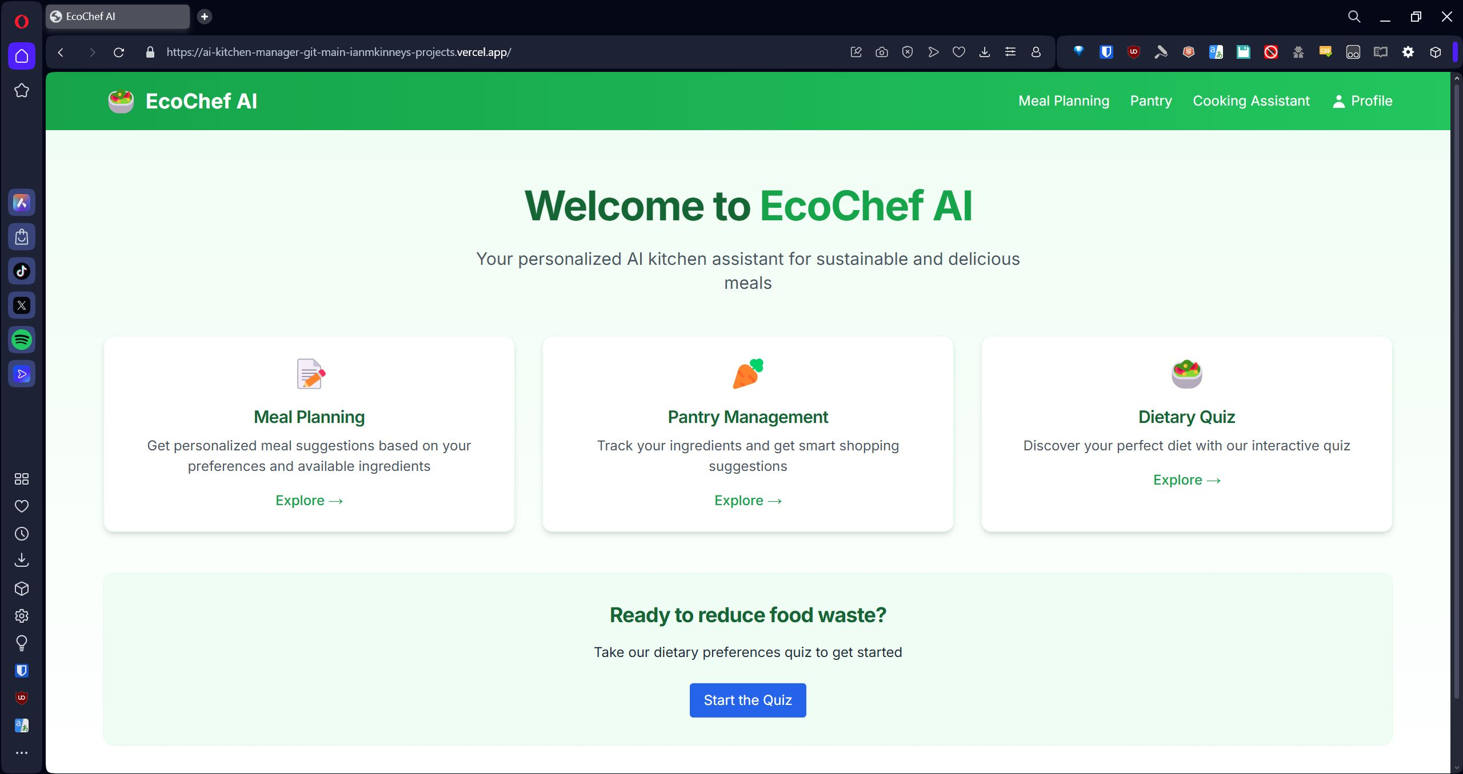

## Dietary Quiz

Clicking on the Dietary Quiz button takes the user to a short 10 question quiz that will tell EcoChef AI how to plan meals.

### Question 1:

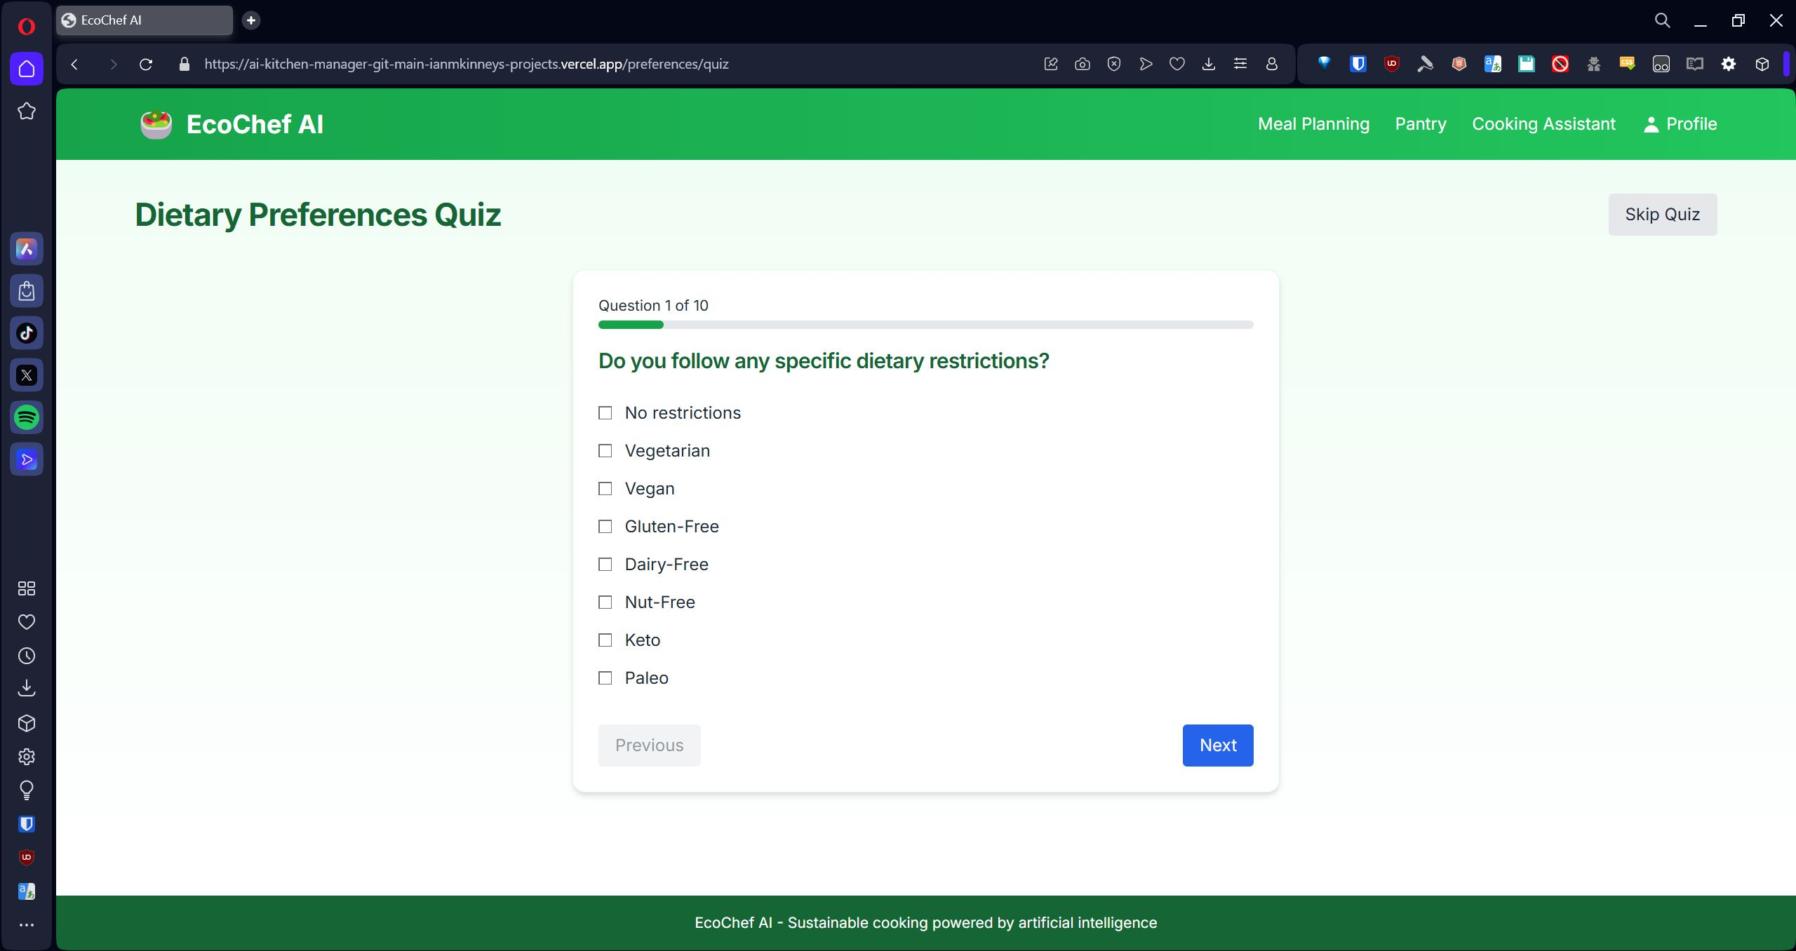Question 1 asks the user “Do you follow any specific dietary restrictions?” The user is given 8 options, all of which are selectable: No restrictions, Vegetarian, Vegan, Gluten-free, Dairy-free, Nut-free, Keto, and Paleo. After making their choice, the user can click the Next button after selecting their choice or click the Previous button to go back to the previous question.

### Question 2:

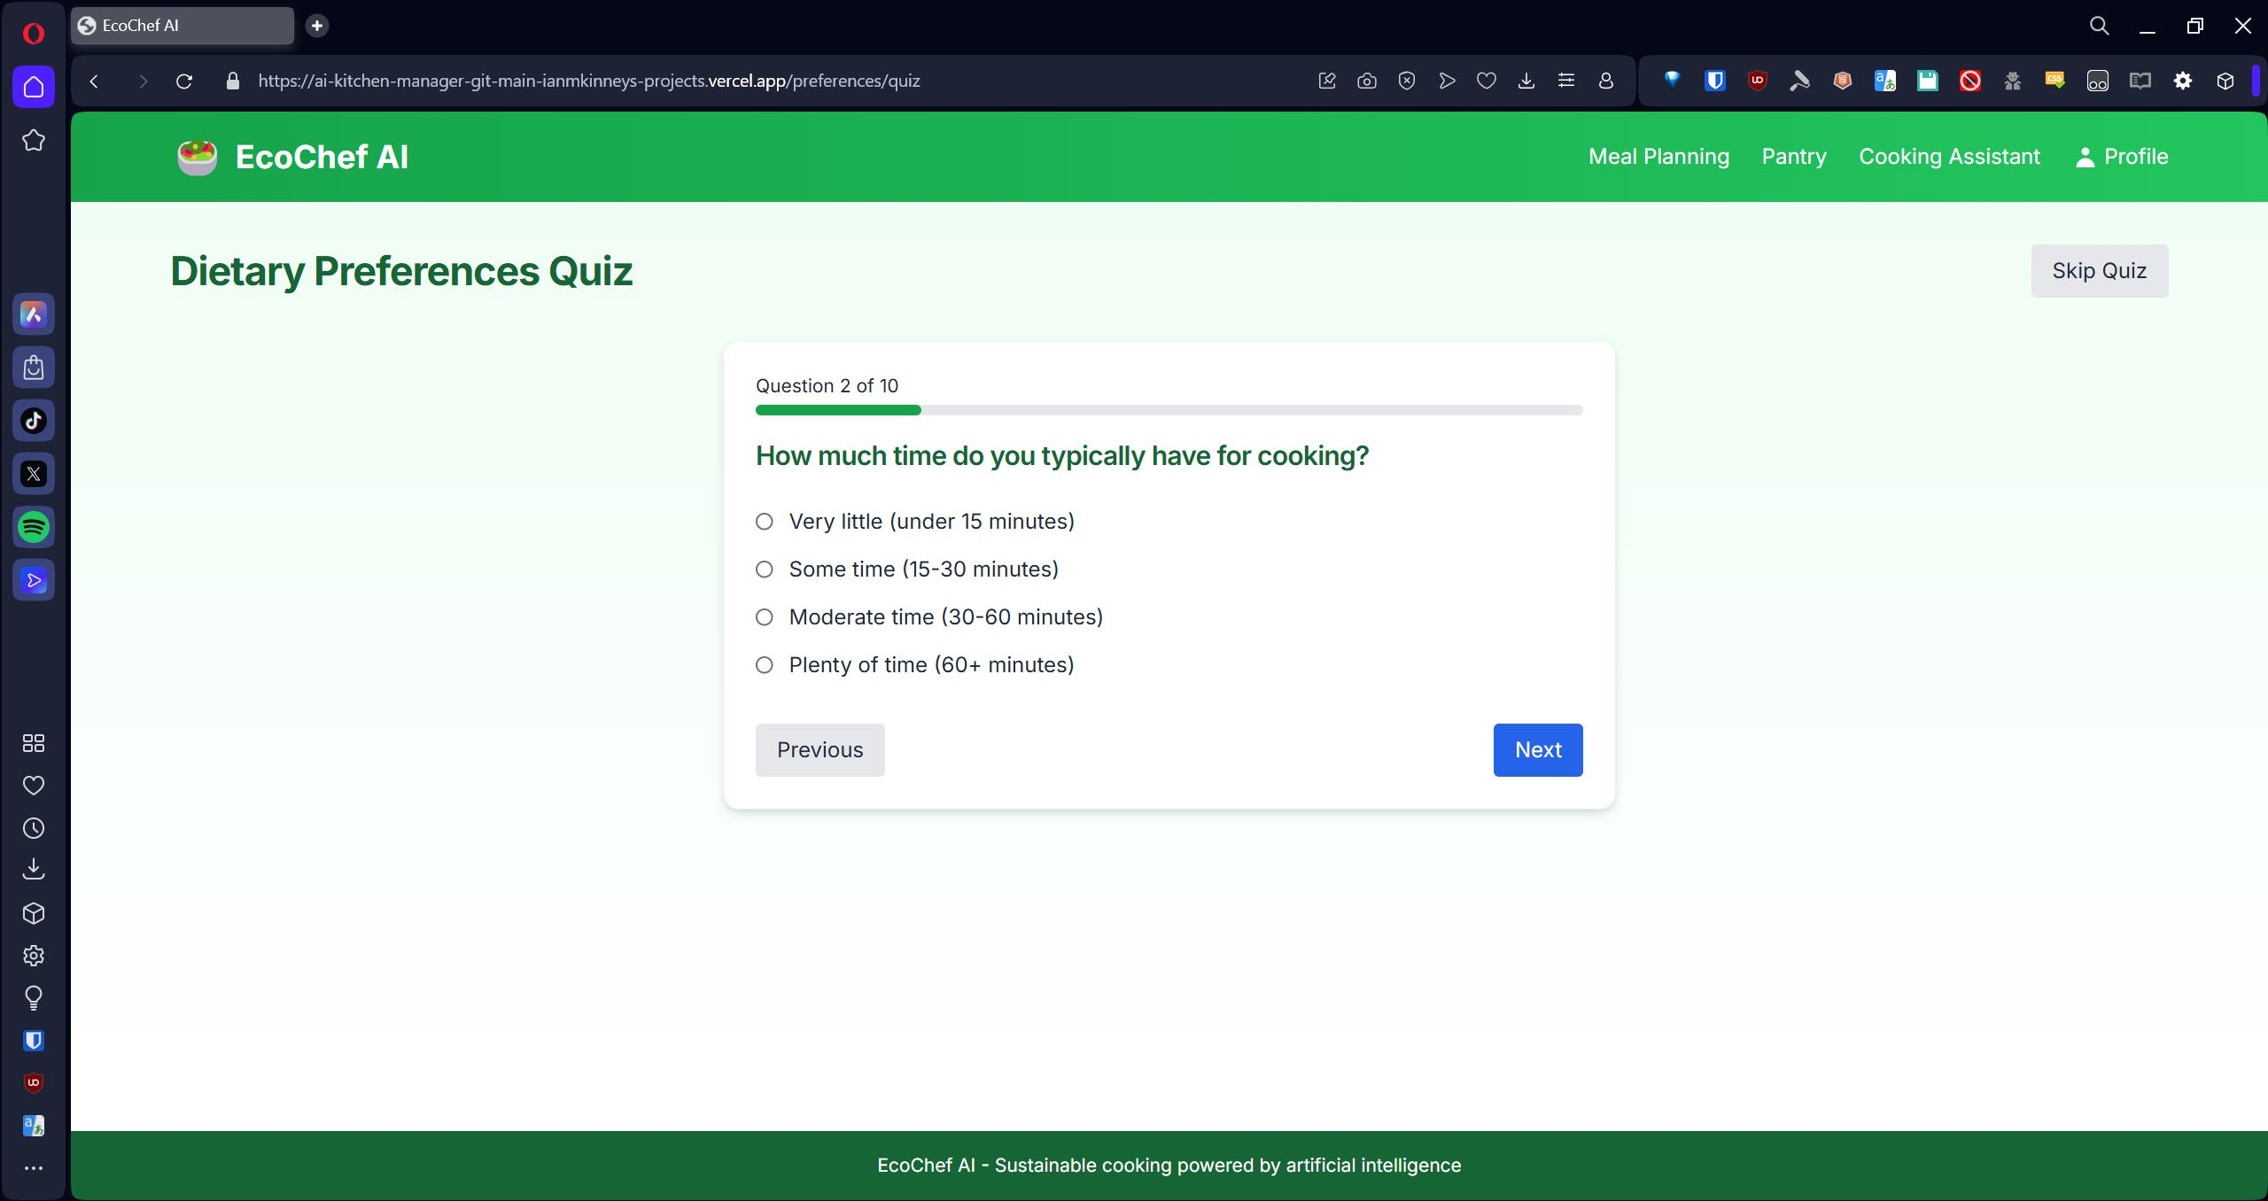Question 2 asks the user “How much time do you typically have for cooking?” Theuser is given four options: Very little (under 15 minutes), Some time (15-30 minutes), Moderate time (30-60 minutes), and Plenty of time (60+ minutes). After making their choice, the user can click the Next button after selecting their choice or click the Previous button to go back to the previous question.

### Question 3:

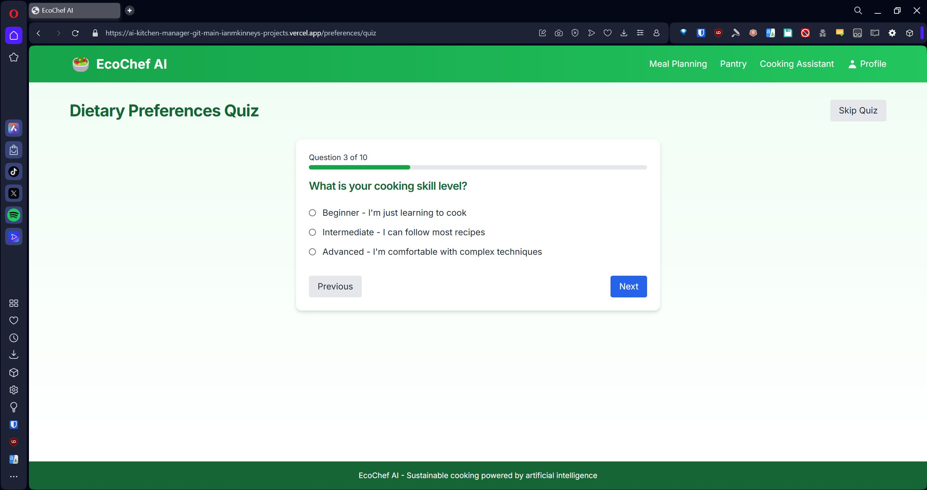Question 3 asks the user “What is your cooking skill level?” The user is given three options: Beginner – I’m just learning to cook, Intermediate – I can follow most recipes, and Advanced – I’m comfortable with complex techniques. After making their choice, the user can click the Next button after selecting their choice or click the Previous button to go back to the previous question.

### Question 4:

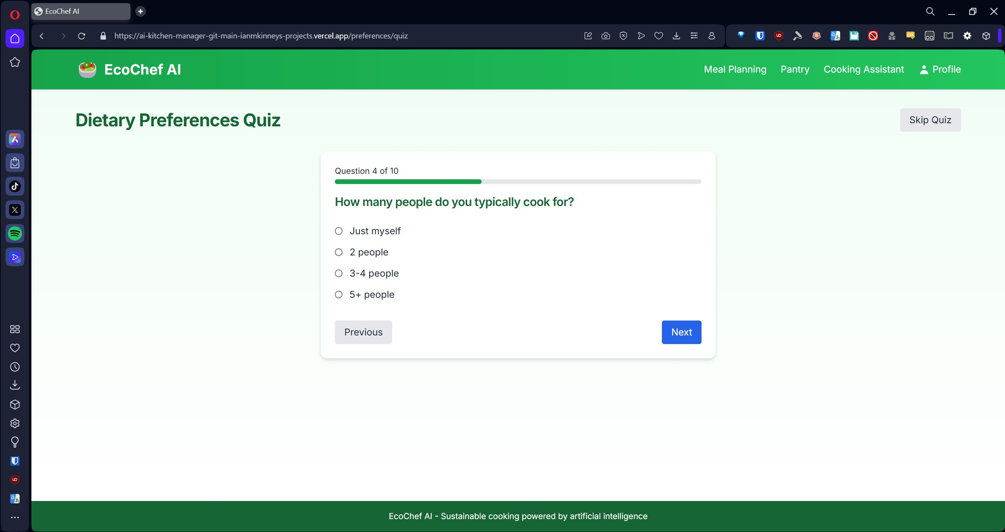Question 4 asks the user “How many people do you typically cook for?” The user is given 4 options: Just myself, 2 People, 3-4 People, 5+ People. After making their choice, the user can click the Next button after selecting their choice or click the Previous button to go back to the previous question.

### Question 5:

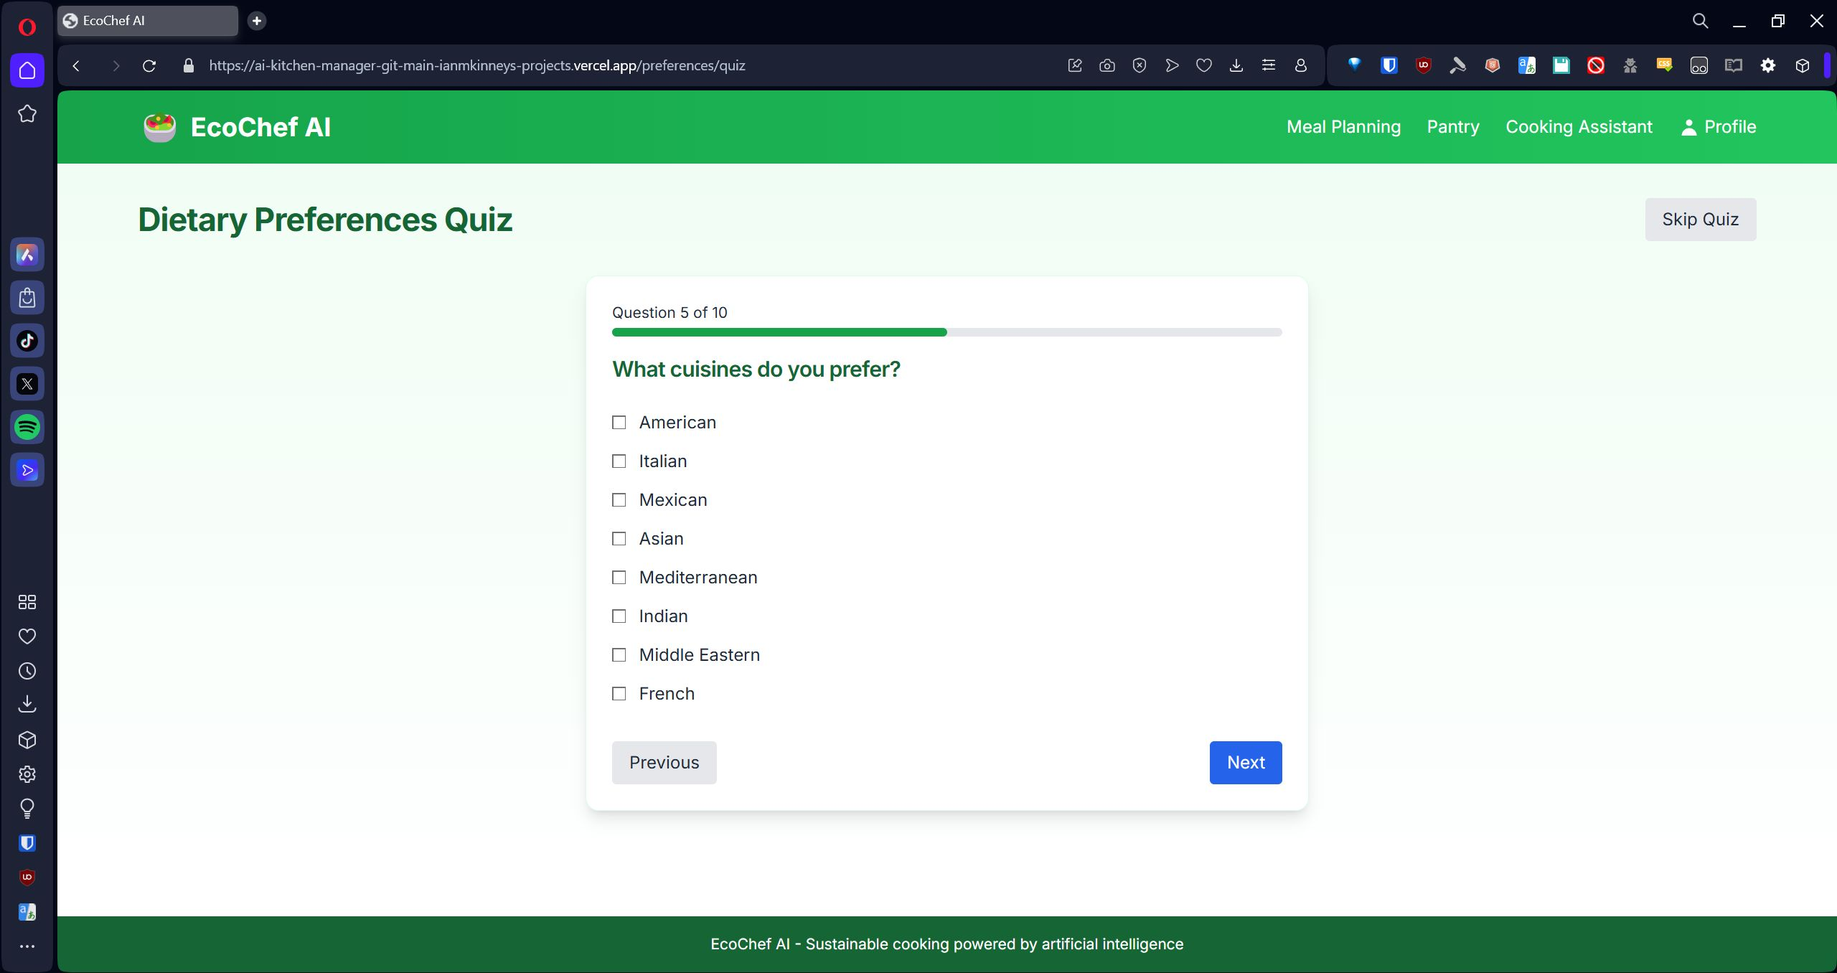Question 5 asks the user “What cuisines do you prefer?” The user is given 8 choices, which are all selectable: American, Italian, Mexican, Asian, Mediterranean, Indian, Middle Eastern, French. After making their choice(s), the user can click the Next button after selecting their choice(s) or click the Previous button to go back to the previous question.

### Question 6:

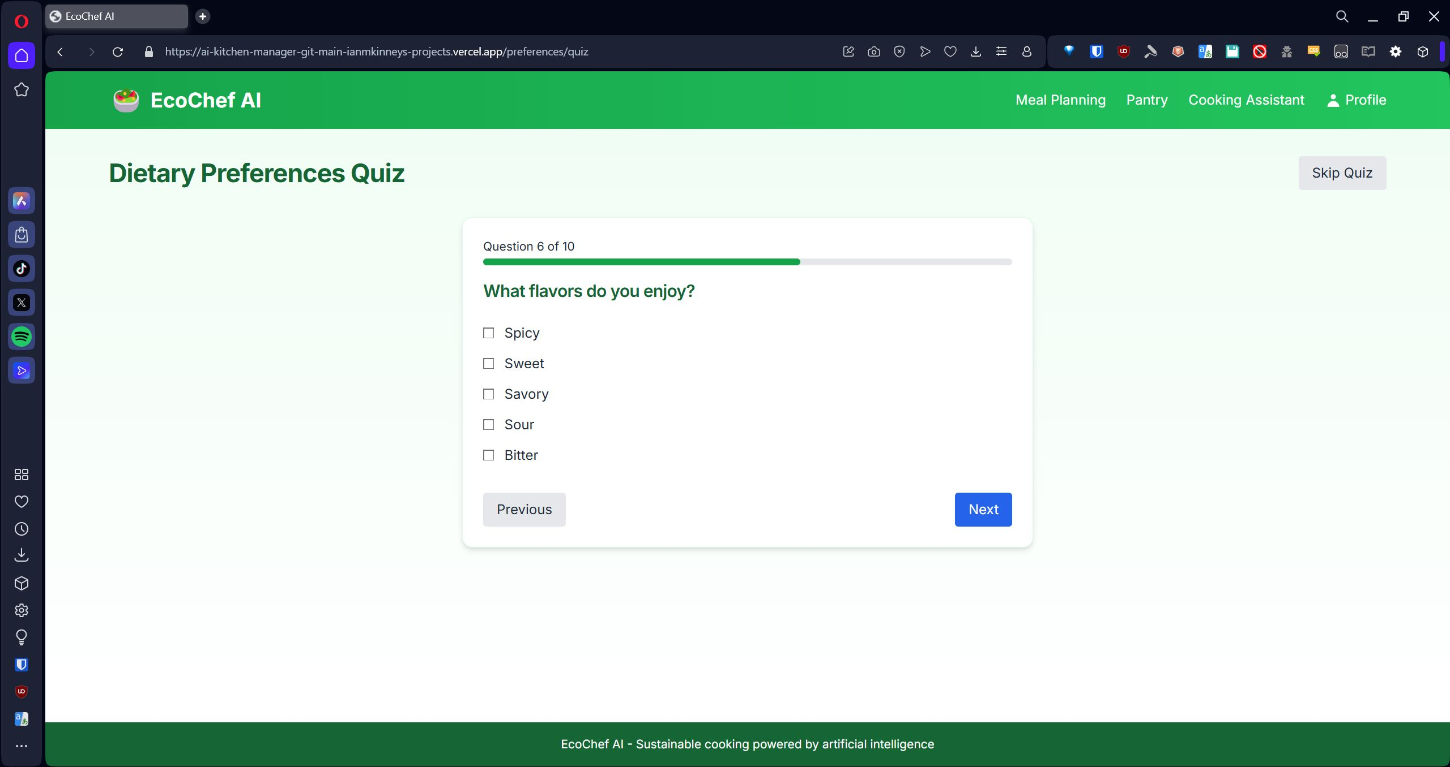Question 6 asks the user “What flavors do you enjoy?” The user is given 5 choices, all of which are selectable: Spicy, Sweet, Savory, Sour, Bitter. After making their choice(s), the user can click the Next button after selecting their choice(s) or click the Previous button to go back to the previous question.

### Question 7:

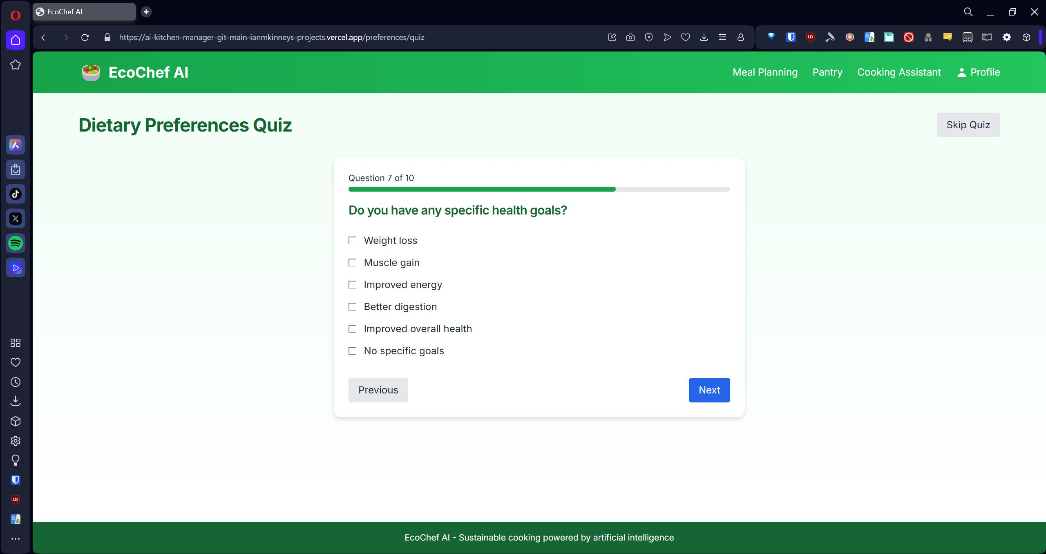Question 7 asks the user “Do you have any specific health goals?” the user is given 6 choices, all of which are selectable: Weight loss, Muscle gain, Improved energy, Better digestion, Improved overall health, No specific goals. After making their choice(s), the user can click the Next button after selecting their choice(s) or click the Previous button to go back to the previous question.

### Question 8:

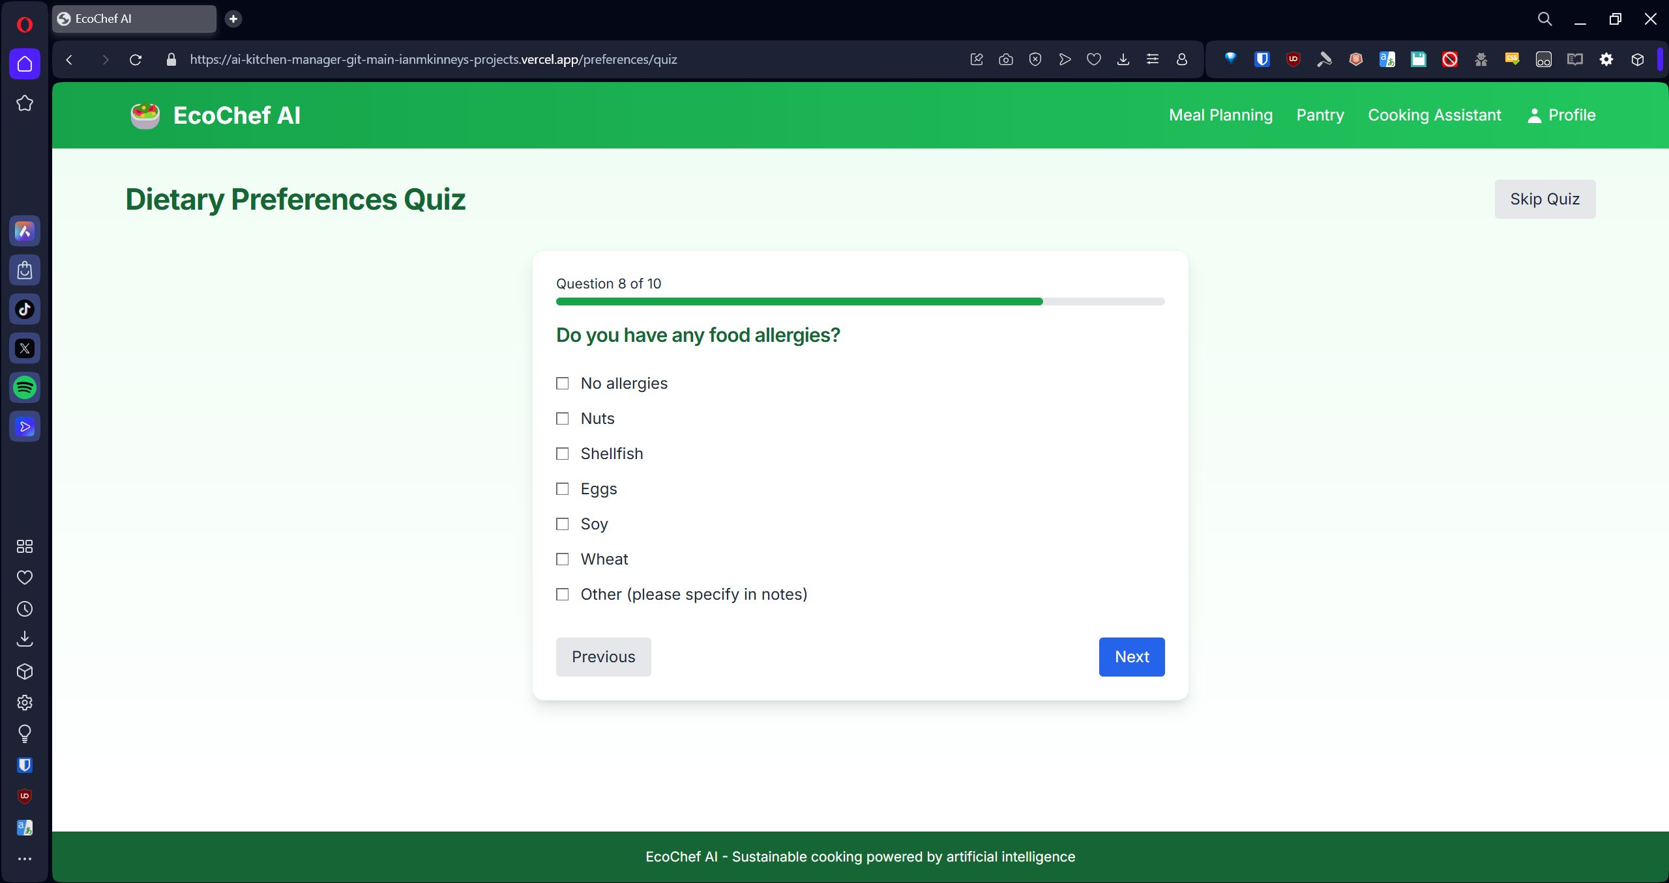Question 8 asks the user “Do you have any food allergies?” The user is given 7 options, all of which are selectable: No Allergies, Nuts, Shellfish, Eggs, Soy, Wheat, Other (please specify in notes). After making their choice(s), the user can click the Next button after selecting their choice(s) or click the Previous button to go back to the previous question.

### Question 9:

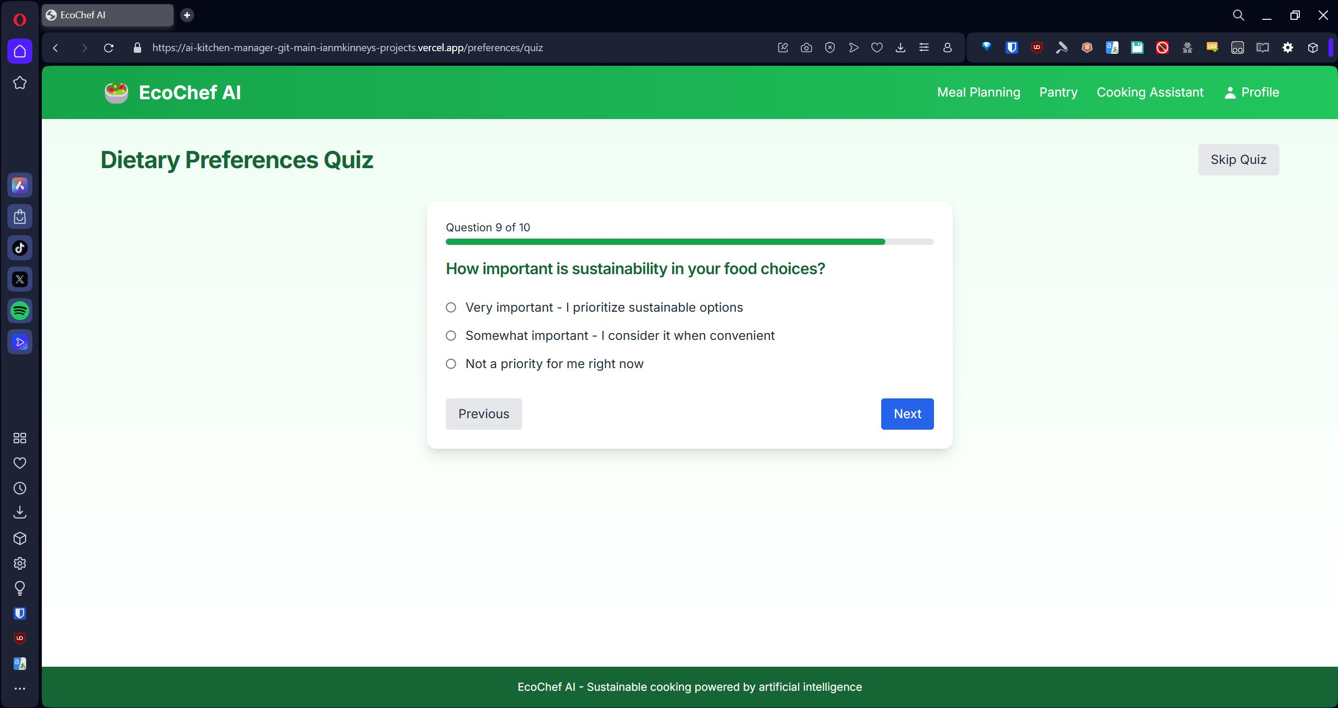Question 9 asks the user “How important is sustainability in your food choices?” The user is given 3 choices to choose from: Very important - I prioritize sustainable options, Somewhat important - I consider it when convenient, Not a priority for me right now. After making their choice, the user can click the Next button after selecting their choice or click the Previous button to go back to the previous question.

### Question 10:

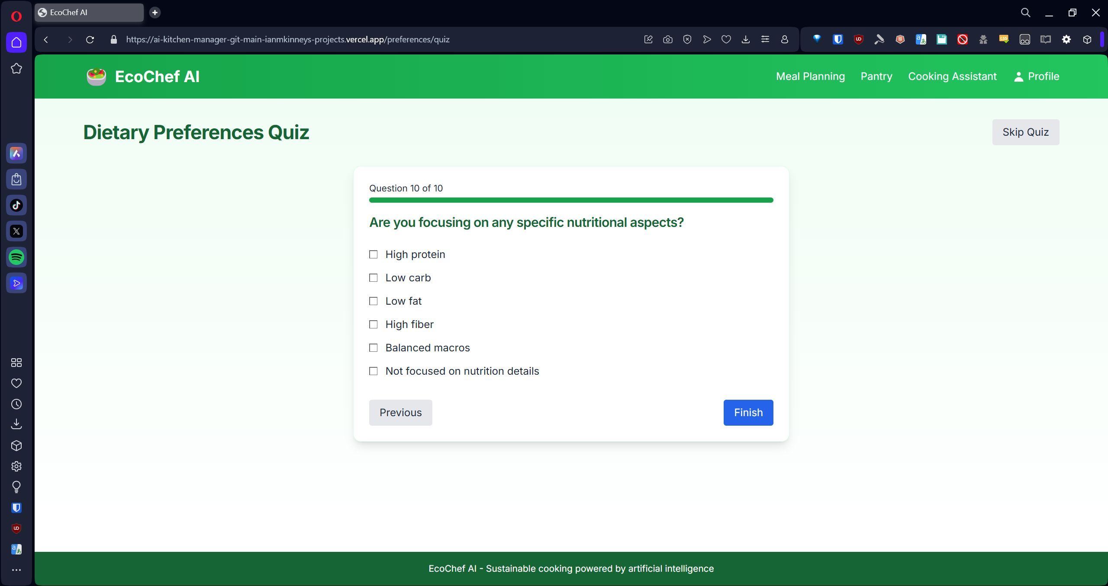Question 10 asks “Are you focusing on any specific nutritional aspects?” The user is given 6 options, all of which are selectable: High protein, Low carb, Low fat, High fiber, Balanced macros, Not focused on nutrition details. After making their choice(s), the user can click the Submit button after selecting their choice(s) or click the Previous button to go back to the previous question.

Selecting the Submit button takes the answers from the quiz and prepares a Personal Profile. The user can click the Update Preferences button to retake the quiz. The user is also given a Get Personalized Meal Plans button that will take the user the Meal Planning Page.

## Meal Planning

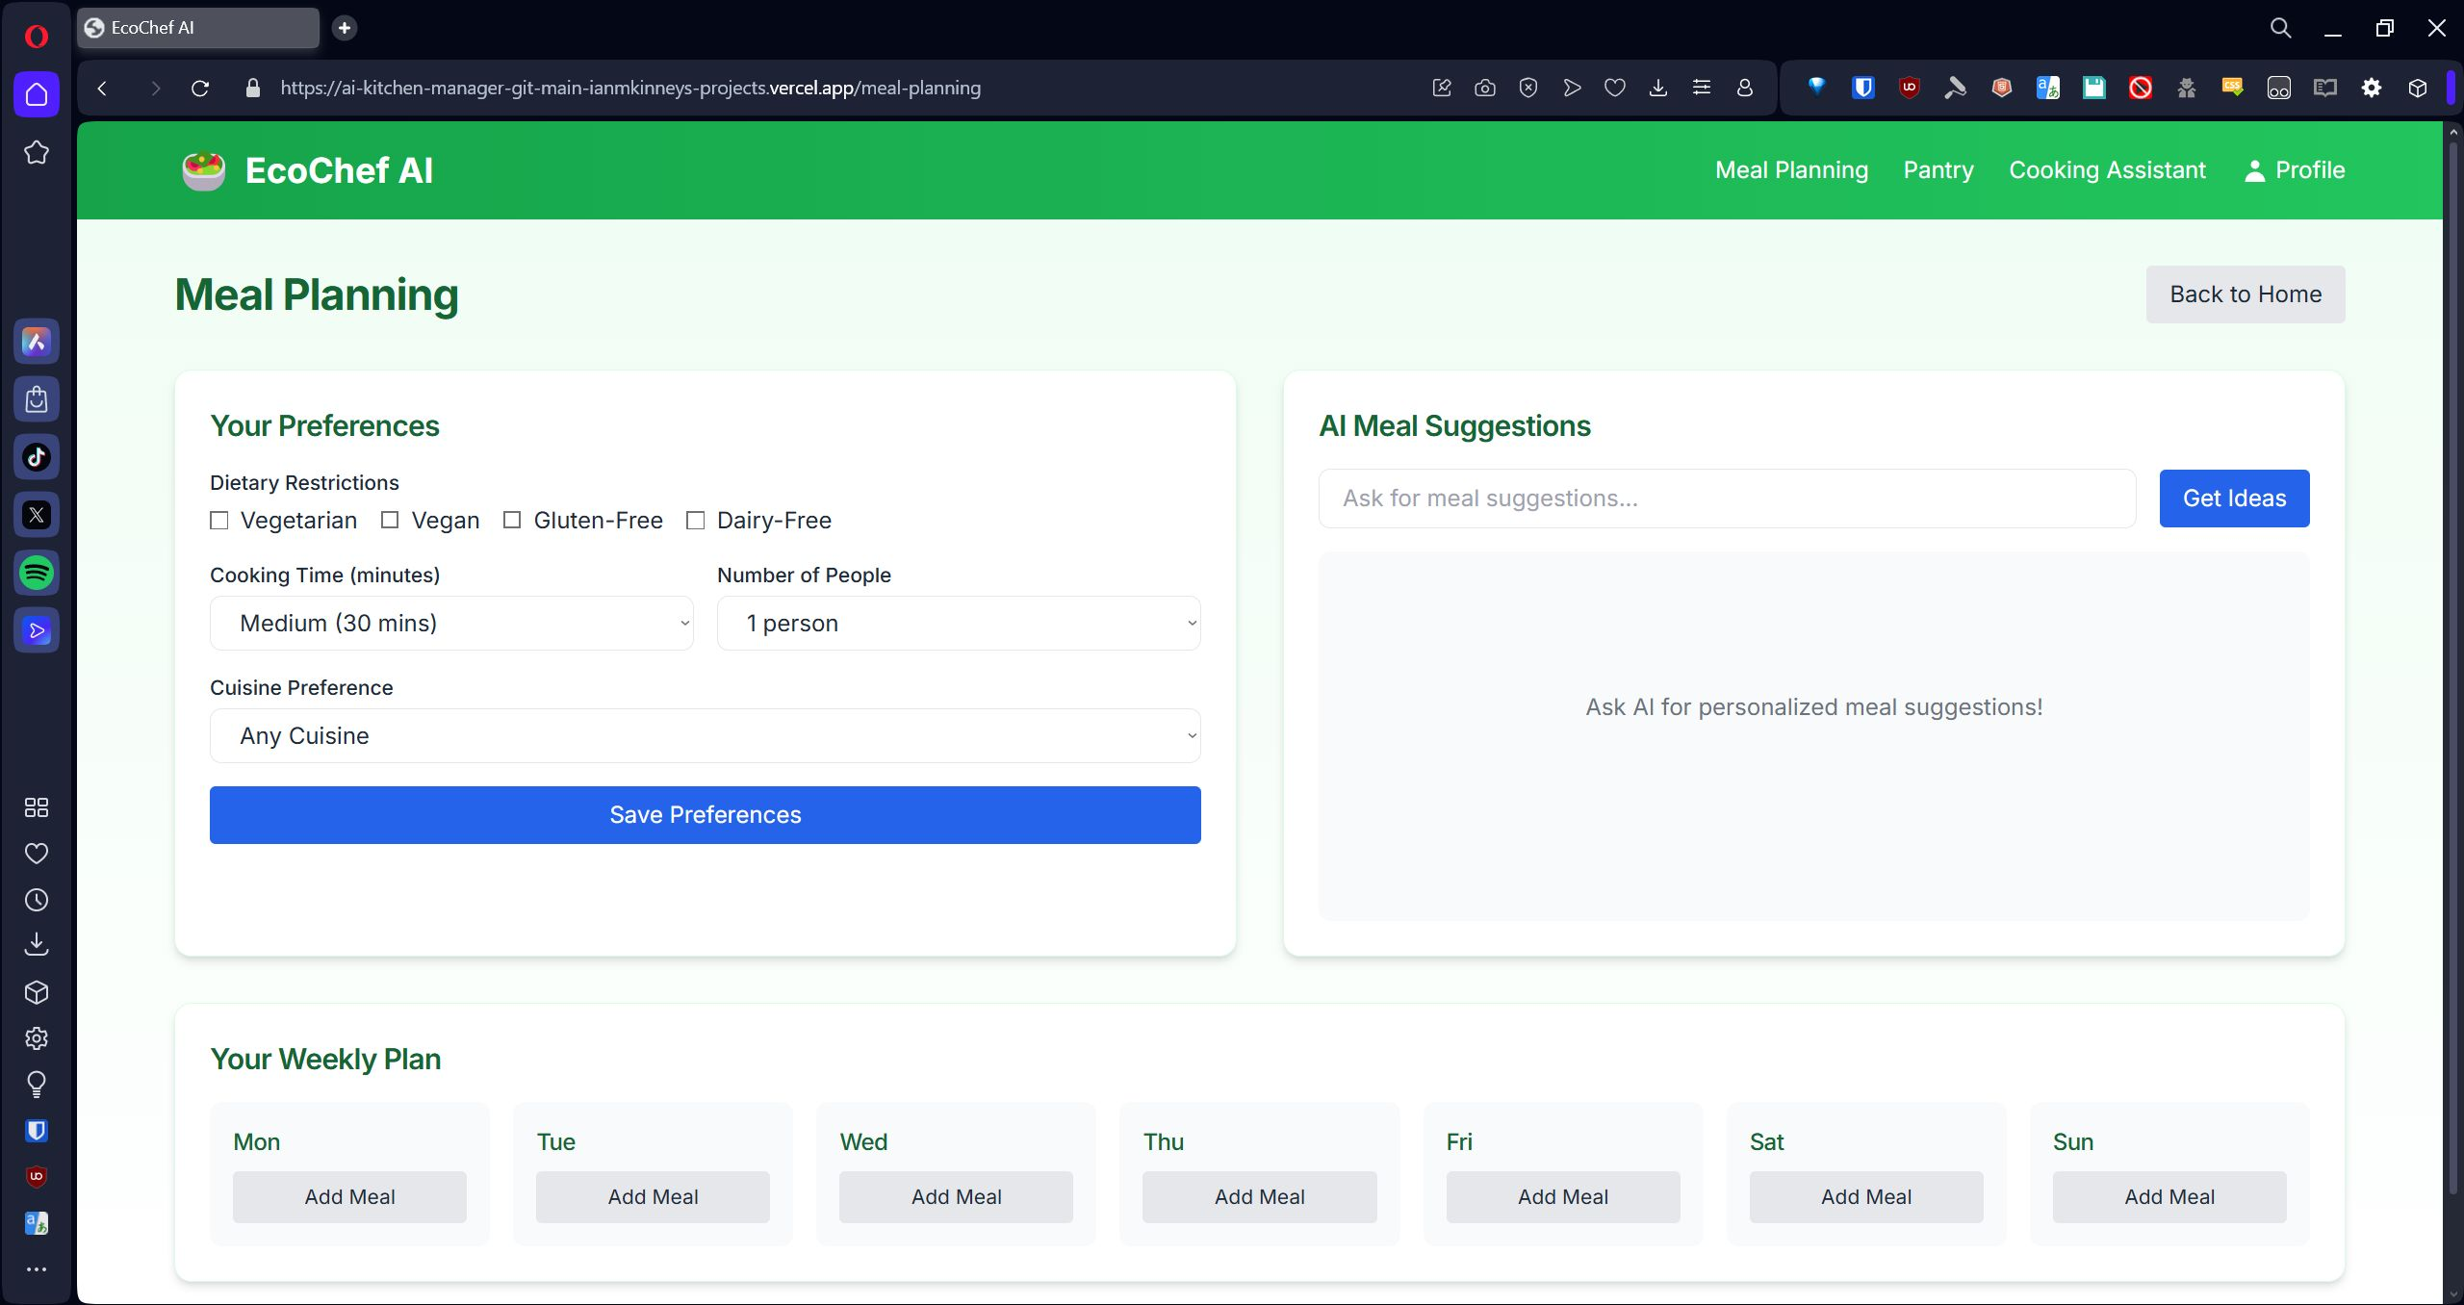The Meal Planning Page shows a selection of the user’s preferences, an AI Meal Suggestion box, and a Weekly Plan for meals.

### Your Preferences

The user can choose from 4 Dietary Restrictions: Vegetarian, Vegan, Gluten-free, Dairy-free. The user is given a drop-down menu to choose from for Cooking Time: Quick (15 minutes), Medium (30 minutes), Long (60 minutes), Any duration. The user is given another drop-down menu for Number of People: 1 Person, 2 People, 4 People, 6+ People. The user is given another drop-down menu for Cuisine Preference: Any Cuisine, Italian, Mexican, Asian, Mediterranean, Indian, American. There is a Save Preferences button.

### AI Meal Suggestions

The user is given a text entry box. The user can use natural language to type a meal idea request. Once the Get Ideas button is clicked, the request is sent to the AI. Using the user’s preferences and Pantry contents, the AI provides a meal idea. The meal idea gives several options with ingredients, instructions, shopping suggestions, and sustainability tips.

## Pantry Management

The Pantry Management Page has the Current Inventory and AI Shopping Assistant areas.

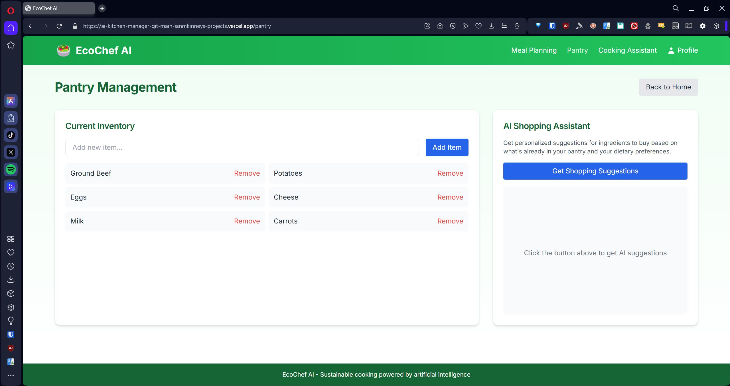

### Current Inventory

The Current Inventory section allows the user to enter an ingredient into a text entry box. When the Add Item button is clicked, the ingredient is added to the list. Each item in the list has a Remove link. Clicking this link removes the ingredient from the list.

### AI Shopping Assistant

The AI Shopping Assistant section has a Get Shopping Suggestions button. When clicked, the AI uses the user’s dietart preferences and provided Pantry items to suggest additional ingredients to purchase. Recipe Suggestions and Sustainability Tips are also supplied in the response area.

## Cooking Assistant

The Cooking Assistant Page provides a Find Recipes section and a Chef Claude section.

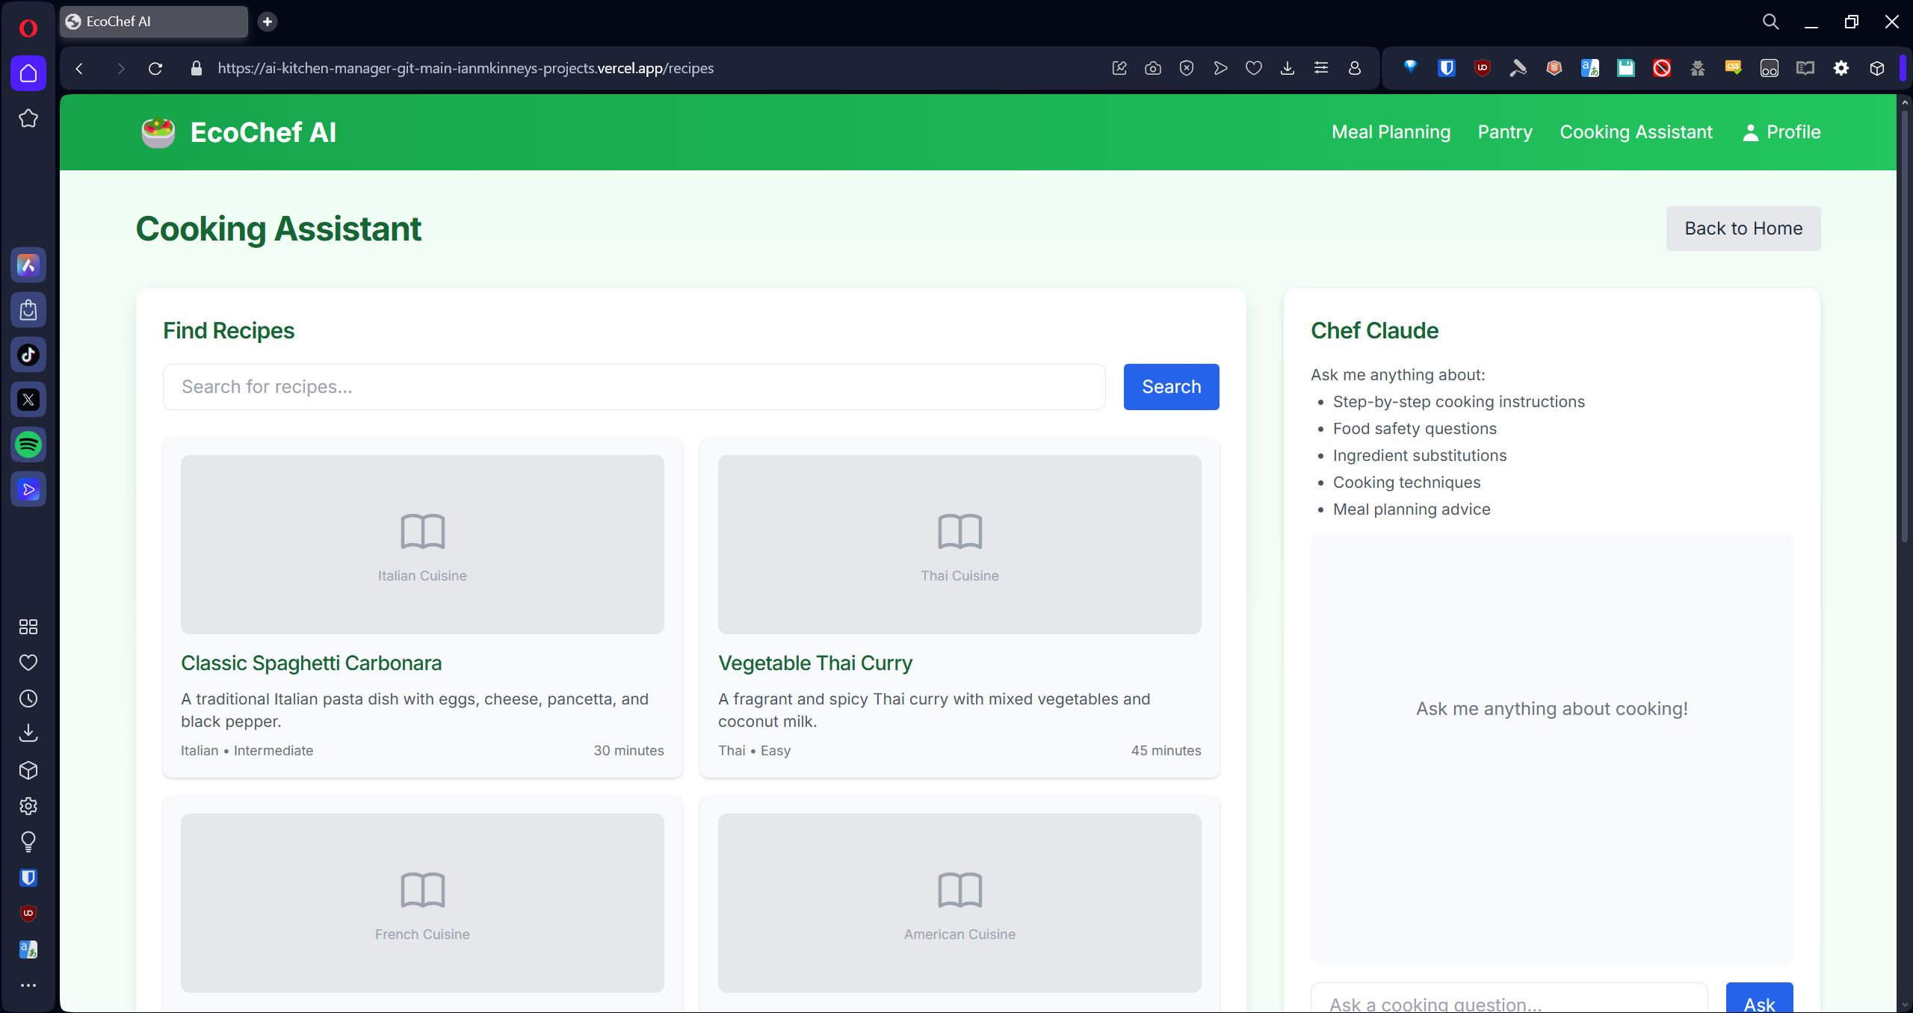

In the Find Recipes section a text entry box to search for recipes that have been preselected. The Chef Claude section provides a text entry box to ask the AI for responses such as step-by-step cooking instructions, food safety, substitutions, techniques, and advice.

## Project URL

EcoChef AI can be found at <https://ai-kitchen-manager-git-main-ianmkinneys-projects.vercel.app/>

## Git Repository

EcoChef AI has a Git repository at [https://github.com/ianmkinney/ai-kitchen-manager](https://github.com/ianmkinney/ai-kitchen-manager.git)

## Libraries and Frameworks

For this project, we chose to use Next.js and Vercel for a sleek user interface and the ability to have backend functions in our applications.   
  
Next.js has server side function declarations as well as client side, making it easy to have secure API calls to external services.   
  
We used Claude 3 haiku for our agents in initial testing. Will be bumping models up as we define the workflow more for our users.

## Individual Reflections

### Jason Scott

I attempted to contribute code to the project by supplying the initial code to the project. However, I had a drive corruption issue that rendered my drive inaccessible. My team members stepped up and made a working prototype that works well for an initial alpha. There are several tasks that are working at a good stage to show the future path of the project. My final contribution was going through the prototype and making the Intruction tour. My biggest difficulty, beyond the drive crash, was learning the codebase for the project. This is a skill I will be able to take with me as I progress in my programming and IT career.

**Kyonne Robinson**

My immediate contribution to the AI Kitchen Manager system's development was to test the website itself. This required investigating the platform's various capabilities, making sure the interface worked correctly, and confirming that the system reacted appropriately to user input. My objective was to assist in locating any errors or discrepancies that would compromise the tool's functionality or user experience. Assuring the correctness of the data the system was processing was one of the biggest challenges I faced throughout testing. It was occasionally difficult to tell if the problem was with the interface, the core logic, or variations in user input because the outputs didn't always match the intended results exactly. Working on the high-fidelity prototype taught me how to provide structured, constructive criticism based on test findings, which was a very useful ability. I developed my ability to pay close attention to user interaction, properly record problems, and make suggestions for enhancements in a way that aided the development process. This ability not only raised the caliber of our finished product but also aided in my development as a more cooperative and careful team player.  
  
**Ian Kinney**  
  
My contributions included team communication and developing of the application. As I am a software engineer by trade, I decided to use my skills to get the repository up and running, and a development environment deployed for our team to use. Planning on passing more development work on to the team as I teach them more about the initial codebase. All of the contributions from the team helped build out the application, as I used a lot of the material we had worked on to create the initial prototype of our app. Looking forward to working more with the team to fix all of the bugs and make this a great product for people. They have already had great ideas to make the app better and we have made great progress so far. The biggest skill I have developed is taking feedback and creating something better than I could by myself. Looking forward to building on that more.

**Anthony White**

My contribution to this milestone is to navigate through the Eco Chef Ai applications and discover any weaknesses in the interface and report it back to our creator, Ian. After a couple of back and forth on the issues, they are later to be resolved and updated on to the application itself making it better than it was initially. I was also the test dummy in acting as a user wanting to use the application for cooking and discussing with the Ai question section to learn more on how to cook a certain meal and add an inventory count of my ‘Fridge’ for the Eco Chef Ai to work off it. We also discussed more on what to add on to our protype which would be a profiling section for the users and a login process which will later be installed into our application. After seeing the protype so far and how easy the interface is becoming, I am excited to help and work with the team on adding in more features to our creation.